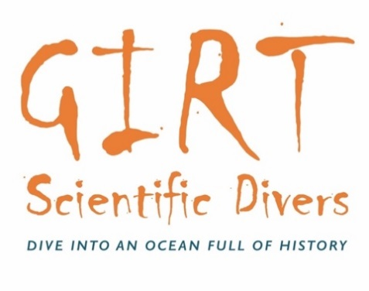

**When:** Saturday and Sunday 20 and 21 August 2022

**Time:** 9am to 4.00pm-ish

**Where:** HMS *Sirius* and Norfolk Island Museum, No.9 Research Centre

**Who:** Dr Andy Viduka (maritime archaeologist, conservator and founder of GIRT Scientific divers)

**Register at:** <https://www.girtsd.org/register>

**A citizen science project for people who want to dive with a purpose and who are passionate about shipwrecks and other underwater cultural heritage**

**Background:** The citizen science project Gathering Information via Recreational and Technical (GIRT) Scientific Divers is a no-impact public archaeology program that aims to:

* enable better understanding of the condition of underwater cultural heritage sites and the factors driving their preservation or deterioration; and
* encourage interested people to have an active and positive public archaeology role.

GIRT members ‘adopt a wreck’ they like and agree to monitor the site periodically using the GIRT methodology. GIRT members agree to share their collected data with the public so as to inform everyone about the condition of the site. For more information about GIRT go to the ABOUT tab on the website <https://www.girtsd.org/> and to register your interest in participating about the training go to JOIN tab and email [girtscientificdiver@gmail.com](mailto:girtscientificdiver@gmail.com).

This GIRT training will be conducted over two days. The second day of training will be focussed on diving using the methodology (subject to weather).

Supported by: